1. Good afternoon every one, my name is Do Dung Vu, I am the PhD student. Today, I would like to present about my proposal which is “ MediatorBot: A mediator bot for supporting collaborative e-learning using an Intelligence Tutor System”

* Before presenting, I would like to say thank with prof Sylvie Ratte who is my supervisor
* Now I turn to the Overview of my presentation

1. I would like to present 6 parts:
   1. part 1: introduction will address about the general information of Intelligent tutor system which is one of the famous effectively education system. Then, I will discuss about the context of application including the literature survey.
   2. Part 2: I would like to mention about the currently problem statement in the tutoring system which has 07 issues in the collaborative student learning online. And emphasize what is the main problem of collaborative student learning online can be solved by an intelligent mediator. And what is the mediator functions?
   3. Part 3: Motivations: At this part I would like to address about the motivation of mediator system
   4. Part 4: I would like to present the main objectives of Mediators
   5. Part 5: To implement the mediators bot, I turn to the methodology and some achievements. Thanks to Ai-educate company and Mitacs which is using my research results, give me the material of researching and the grants, respectively
   6. Part 6: is my work and research plan to make it come true
2. Now, here is the analysis and prediction of Ai application chance in education at US market from 2017 to 2024.

The market size and forecast increase 15 times for 7 years. The technology trends are ML, DL< NLP. Especial NLP gets a lot of percentages (68.28%), ITS is 21.73%, especial the LP and facilitor are 56.37%. It means that there is a very good chance for us to work on.

1. Now I would like to discuss about the history or time life or Intelligence Tutor System (ITS) which have been developed for more than 20 years.

* The left hand figure displays a timeline of ITS, loosely arranged by three foundational lines of research at the top of the diagram. The timeline is organized according to the date that each project was first published

Because of the limited time, I would like to explain some modern ITS such as: **AutoTutor** and related systems in the family have tutored computer literacy (Graesser et al. 2004a), conceptual physics (Graesser et al. 2003a; Rus et al. 2013c; VanLehn et al. 2007), biology (Olney et al. 2012), critical thinking (Halpern et al. 2012; Hu and Graesser 2004; Millis et al. 2011), and other topics.

Work has also been conducted to expand the accessibility of AutoTutor, such as a simplified open source release (**GnuTutor**; Olney 2009), a constrained version designed for webbased authoring and delivery (AutoTutor Lite; Hu et al. 2009), and a framework for sharable web-based tutoring objects (Sharable Knowledge Objects; Nye 2013; Wolfe et al. 2012)

Other successful tutoring systems, such as **Cognitive Tutor** (Aleven et al. 2009; Ritter et al. 2007) and Andes (VanLehn et al. 2010), organize their interactions around problem-solving interactions without discourse

Tutoring strategies included extensive use of deep-reasoning questions and their answers (AutoTutor and later **iDRIVE**), collaborative lectures (**Guru**), learning progressions (**DeepTutor**), reading comprehension strategies (**iSTART**, **iSTART**-ME), writing strategies (**Writing**-**Pal**), affect and engagement detection (AutoTutor Affect-Sensitive, Supportive AutoTutor, **GazeTutor**), and so on

* The right column presents two examples of ITS which are AutoTutor and Korbit(or LILA). Where AutoTutor is an intelligent tutoring system that holds conversations with the human in natural language. AutoTutor has produced learning gains across multiple domains (e.g., computer literacy, physics, critical thinking). Three main research areas are central to AutoTutor: human-inspired tutoring strategies, pedagogical agents, and technology that supports natural language tutoring. And Korbit is an intelligent tutor powered by state-of-the-art Artificial Intelligence. Decades of research on natural language processing, combined with the recent resurgence of Deep Learning, have finally made a system capable of tutoring students in many different subjects possible

1. On the other hand, I would like to emphasize that the ITS has three main purposes as following:

* Help students construct expressions of material as answers to questions and solutions to solve the challenging problems
* Ask questions that tap deep levels of reasoning and that involve collaboration
* Solve problems that involve deep argumentation

1. ITS is applied in many scenario, in this proposal, I assume that ITS is working on the Elearning environment. At this scenario, the students study in a given domain-specific (e.g., statistic). During this course, the students must collaborate to solve some given assignments or topic based on their conversation by following their groups. The Intelligence Tutor System (ITS) helps Professor to monitor the progress of students and Admin to encourage their study.
2. There are several Intelligence Tutor Systems working on this area. For example, the ITS monitors students’ knowledge, skills, and psychological characteristics and response in 2014. Or in 2016, the conversational agents have talking heads that speak, point, gesture, and exhibit facial experes were proposed. At this time, autoTutor and its progenies help students learn by holding a conversation in natural language. On the other hand, the conversational agents improve pear learning through building on prior knowledge was proposed in 2017 which intervenes to link student’s contributions to previously acquired knowledge for improving both individual and group studying in higher education
3. However, the students collaboration online has many problems which make it ineffectively such as:

(1): the student has conflicts works in the group

(2): the selection of the groups is not good

(3): the students don't have enough group-work skills

(4): some students want to work alone or become the free-riders

(5): the possible inequalities of student abilities appears in the group

(6): some members do not commit to working in the group with their responsibilities

(7): the assessment of individuals within the groups is not fair

9. According to the literature survey, I figured out that most of these problems above are inter-related as the figure. The problem #3#1 are the main cause of problem #4, the problem #6 is the cause of problem #7, and the problem #2 is the cause of problem #5

10. Hence, if we solve the main cause problems, the collaboration online learning will be fine and much useful. However, I observed that #3 can be sovled by orientation training from administrator, #6 and #2 must be worked by professor. Then, the #1 should be solved by the ITS. But how?

🡪 We want to solve the problem of student conflicts by using the ITS

11. To do so, we consider the scenario as the pictures above. The right hand picture is the original ITS which is mentioned in the paper at 2015. Where

* **Student Model** tracks information of individual student (e.g., tracking possible misconceptions, time spent on problems, hints requested, correct answers, etc). One of the task in this model is the predicting student performance (PSP) which is taken into account in this study.
* **Domain Model/Knowledge** represents expert knowledge or how experts perform in the domain. It contains the information that the tutor will use to teach the students. For example, it includes definitions, processes, or skills needed to multiply numbers, generate algebra equations, etc [1]. **Tutoring/Instructor Model** represents teaching processes/strategies. For example, information about when to review, when to present a new topic, and which topic to present is controlled by this module. The student model is used as input to this module.
* **User Interface (Learning Environment)** presents the methods for interacting between the students and the systems. An important problem in this module is how the tasks (materials/learning objects) should be presented to the students in the most effective way
* The left hand picture is the ITS with our plug-in Mediator.

12. Hence, MediatorBot generates the hints, identifies the debated problem, the opportunities for intervention, and answers the related topic question of students to encourage the users to collaborate more effectively in the online group learning with low price in the specific-domain

13. To make it more intuitively, I would like to explain the scenario:

(1) The happy mediatorbot is listening the conversation of both students, they are augmenting about the definition of **Regression** , one of them disagree with the other.

(2) The mediatorbot figures out the topic which they are talking about is the “definition of regression” and because they are contradict together, so she decides to intervene now, then, she prepares the right definitions (e.g., Regression and Classification) ~Hints

(3) She sends the hints to the user1, user2 (assumes that the level of two students is the same)

(4) After that, both of them will be happy and continue discuss about the topic

14. So, what is the motivations of the Mediator Bot?

During a long time, 1 professor broad casts information of lecture to many students, and in currently, the modern classes have some tutors to help students study and follow the lecturers easily. However, it costs a lot, and has many limitations such as: location, capacity, language, working time. Especial in the student conflict conversation, the tutor must work hard to solve this problem and has a lot of stress.

Hence, the MediatorBot will be the future state-of-the-art interventions with low price for intelligent tutor system. Moreover, it will encourage student collaboration online by figuring out and solving the relevance topic student conflict. On the other hand, it is easily scalable, so many students on the world will have the smart, friendly tutor with low price.

15. Our research proposes a smart Mediator to support constructive discussion based on Intelligent Tutor System with three main objectives as following:

* Generate hints to help users solve the topic or problem automatically
* Listening the students conversation, identify the debated problem
* Analysis the conversation, Identify the opportunity of intervension in the conversation to resolve the conflict

16. Here is the general structure of the mediator system. According to the diagram, the Mediator has to work on there things:

(1) Preparation: Mediator Get data from internet, text book, preprocess dataset, classify the definition, and generate the hints

(2) Listening: After have the hints or solution dataset, Mediator listening the conversation, Identify the debated problem

(3) Intervension: During the monitor of conversation, Mediator Identifies the opportunity of intervension and gives the hints or solutions to the students

17. Let me go to the 1st Objective which is “ Generate hints to help users solve the topic or problem automatically”

18. Here is the general structure of 1st Objective.

A. Data Preprocessing: Crawl data, clean data, and save data

B. Definition Processing: By using the clean data, the component definition extractor and classification are proposed, after that we save the definition to the dataset

C. Hint generation: In this blocks, we propose 5 components: Hints discriminator (ordering the hints based on the level of Student where students must do a quiz, then we evaluate the level of student by score A.B.C.D and F. According to the conversation, two components named question and answer recognition are considered. Based on the kind of hints, question and answer recognition, the hints are generated by hint generator components. After that, hints will be save to the hints dataset.

19. One of the most important work in this model is data preprocessing

By considering the content from Wikipedia currently or text book (in the near future), we extract the list keywords of subcategories with the Breadth-first search algorithm based on the given terms such as “machine learning” or “statistic”. After having the list of relevance keywords, we get the content of each respective article. By considering these articles, we clean the Unicode, convert xml equation, clean punctuation, split raw text to line by line sentence. After that, save the clean data.

20. Now we turn to the definition processing phases. At here we have three components: definition extractor extracts the description of each concept. Definition classification classifies type of definition based on supervisor algorithm (good/not good). Because the amount of good definition is much smaller than the ones of not good definition, so we use the oversampling methodology to reweight the Good and Not good samples. The last one is definition dataset with its’ label

21. Now, here is the definition extractor

* Split raw text dataset to the sentence tokens
* Extract the technical keyword acronyms
* Extract subject (noun phase) -> Get the keyword (concept)
* Filter the right keyword (concept)
* Get the description of concept
* Save the list (dict) description of conecept which is called dictionary of definition

So, how to extract the subject of the sentence to get the keyword? To do so, we are using the spacy framework which is [spaCy is a free, open-source library for advanced Natural Language Processing (NLP) in Python. It's designed specifically for production use and helps you build applications that process and "understand" large volumes of text. It can be used to build information extraction or natural language understanding systems, or to pre-process text for deep learning.](https://spacy.io/)

After tokenization, spaCy can **parse** and **tag** a given Doc. This is where the statistical model comes in, which enables spaCy to **make a prediction** of which tag or label most likely applies in this context. A model consists of binary data and is produced by showing a system enough examples for it to make predictions that generalize across the language – for example, a word following “the” in English is most likely a noun.

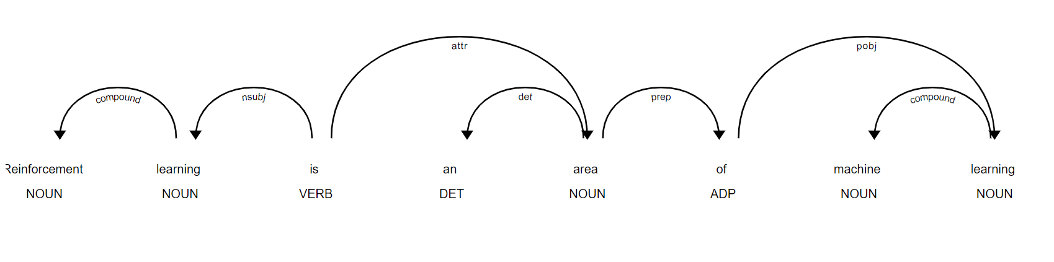

After that, we get the subtree from this tag, then re-build the whole term, here is the “reinforcement learning”. The rest will be added as the description

To extract the acronyms:

*Identifying Short Form and Long Form Candidates*

The process of extracting abbreviations and their definitions from medical text is composed of two main tasks. The first is the extraction of pair candidates from the text. The second task is identifying the correct long form from among the candidates in the sentence that surrounds the short form. Most approaches, including the one presented here, use a similar method for finding candidate pairs. Abbreviation candidates are determined by adjacency to parentheses.

The algorithm is based on the observation that it is very rare for the first character of the short form to match an internal letter of the long form. By adding the constraint that the first character of the short form matches the beginning of a word in the long form, together with the limitation on the length of the long form, the precision is increased by removing most of the false positives, without significantly reducing the recall

22. Definition classification

After we have the definition dataset or the dataset concept descriptions, we turn to the make the definition classification model

* Extract the features -> score table
* Save the score table to the definition dataset
* Classify the G/NG definition based on supervised learning algorithm
* Save the classification model

23. Definition features

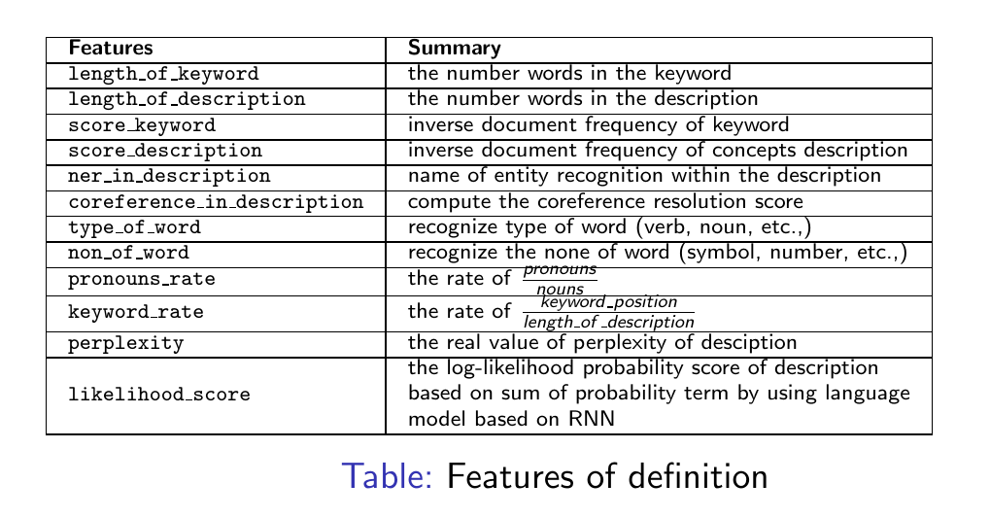

24. Examples

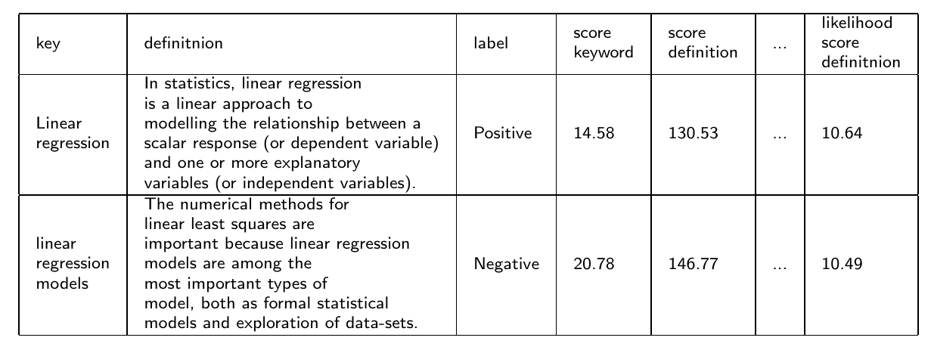

25. Hint generation

After we classify the definition with the oversampling methodology, we turn to hint generation step

* Hints discriminator: classify level of hints based on the student profiles \\
* Question recognition: recognize question of student\\
* Answer recognition: recognize answer of student \\
* Hints generator: generate hint based on hint types, level, and language model \\

26. Hints discriminator

Students have several level, it does not make sense if they get the same hints during the lecture time. Therefore, we discriminate hints based on the label of student level from his profile. Before working with the system, the students are asked to work on the Quiz. By evaluating the quiz results, we make the rank of students which will be utilized in discriminating hints.

27. Because hints, questions, and answers have the interact to each other. So, we have the question and answer recognition components.

The left hand side diagram is the question recognition and the rest one is the answer recognition

** Question recognition:

* We detect the pattern of question words
* Remove the stop word
* Extract the keyword
* Recognize the name of entity in the question (using the frame work spaCy as we mentioned above)
* We know the topic of question

** Answer recognition:

* Remove the stop word
* Recognize the name of entity in the question
* Extract the keyword
* Compute the score of answer (the score is make by similarity function with the given dataset) and make the rank of the answer (the rank is make by computing the log likelihood probability of the answer)
* We know the topic of answer

28. Now we turn to the Hint generator

Based on Hints discrimination, question recognition, answer recognition, definitions, Q&A, and Reference hints, we construct the relevance hints.

29. Construct hints

Here is the features of hints. So the hints are phrased in the form of “ Think about X” or “Consider X” where X is the part of expectation answer. Then we use linear regression model to construct the hints.

30. Examples:

Here is the examples of hints generation

31. Now let me turn to the objective 2: which is identify the debated problem

32. here is the overview of the identify the debated problem. The main idea is the conversation of students which is following on the given topic, they have some conflicts or debated problems related to the given specific-domain topic

The system has three things: Data preprocessing, Network analysis, and Conflict identification

33. Data preprocessing

Here, we crawl data from stackoverflow, hangout, messeger, and slack with the given domain. After that, we clean the content such as: clean the Unicode, equation, punctuation…

34. Methodology;

To find the interesting association or correlation relationship between dominant words, we consider the association rules which is a technique to uncover how items are associated to each other. There are three common ways to measure association

* Support: how frequently the itemset appears in the dataset.
* Confidence: how often the rule has been found to be true.
* Lift: the ratio of the observed support to that expected if X and Y were independent

35. Methodology

We construct the network text of dominant word: include weighted edge result for association rule process

The network text constructed from **words pair** and **word cluster** with regard **to degree centrality and weight degree measurement** can be seen in Figure. In the picture, difference node and edge with the same color means one cluster.

In network analysis, we employ centrality to find the most influential words in the networks and modularity to find words cluster / groups in network.

* Hence, we know the main meaning or problem of a given conversation

By monitoring the student conversation, we get conflict problem related to the topic by mapping conversation network to the clusters analysis

37. Now, let me turn to the last objective named “ intervene in the conversation to clarify the problem”

38. here is the overview of the system, we have 3 components: sentiment analysis, identifiable opportunities of intervention, and clarified problem of conversation. The main idea of this methodology is, we want to monitor the conversation, figure out the contradicts terms related to the topic and the emoticon of users then decide when should intervene to keep the conversation warm up and on track

39. Sentiment analysis

Here, we listen the conversation, extract the contradict terms, emoticons for classifier with prediction model. Then we have the sentiment score of this conversation, after that we evaluate the rank and influence of this sentiment based on there stuff: Question, answer, and comment -> then we cumulate all the score for evaluating the sentiment of conversation

40. Intervention

After we get the score of sentiment and the conflict problem, we compare them to the given threshold which can be updated by user experience learning. Note that, the decision of intervention is only made when the conversation satisfies with two conditions: topic and sentiment to make sure that the students do not argue some un-related topics. After that we clarify the problem of conversation based on the adaptable hints

41. Evaluation measurement

Because this is the conversation between Human and machine, so we prefer to use the users' experiment test to get feedback score in range (1,5) and expert recommendations.

42. How to do that

We approach user experience based on the idea: get the experience, update and improve system based on the feedback, make the new contribution

We evaluate our system by using the user experiments testing.

* students' experiments
* professor recommendations

Users: students at the class offline, students on LILA

friends (if REB is valid) or Amazon Mechanical Turk

43. How to do the evaluation

We set up the environment based on the Facebook messenger and run it on the local host with our system or reuse the LILA system in the mode dev.

Make the report feedback statistic evaluation and use Cohen’s kappa for evaluating the agreement of human and machine experiment

44. Until now, we have some achievements such as:

* 3 years Mitacs accelerate grant for Natural Language Generation for Intelligent Tutoring Systems \\
* Directly apply the results to LILA and Korbit systems at Ai-educate Inc \\
* Get the good feedback from the students though LILA system (Ai-educate has the REB for this experiment)

And here is the result when we implement the hints at McGill

45. Let me turn to my work schedule

Now we are at the end of winter 2018, I will try to apply the REB certificate for this summer, implement the 1st experiment and ready for the 1 paper in the fall season, and after that for the second experiment and 2 paper, and so on.

During the time of researching with Ai-educate and Prof. Sylvie, I am going to make more literature survey to upgrade my knowledge and write the thesis.

I plan to finish my PhD in the Fall season of 2021 (end of Mitacs grant)

THANK YOU